Images of the August 2017 Solar Eclipse Party

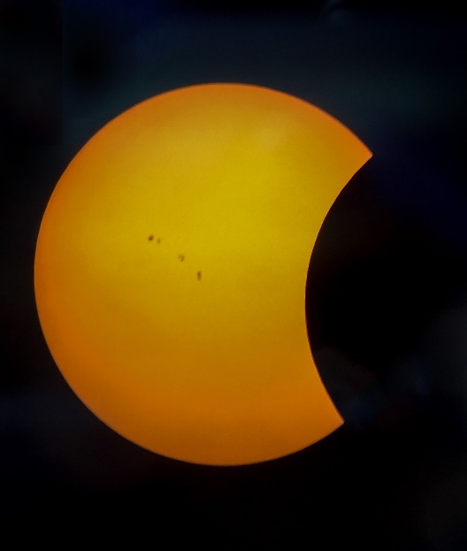The solar eclipse party, sponsored by the Keene City Library and the Keene Astronomy Club, on August 21st from 1-4 pm at the Keene Public Library was a huge success with some two to three hundred people of all ages in attendance.  Many thanks to Gail Zachariah and her Keene Library staff for organizing such a wonderful and successful event.  Solar glasses were handed out and there were tables set up to make solar viewers, telescopes for viewing the eclipse and, inside the library, live streaming of the total eclipse from NASA.

 The weather cooperated to give us clear skies so everyone could get to view and take pictures of the partial solar eclipse.  The eclipse started at 1:28 pm and finished at 3:54pm.

The Astronomy club provided a 4.5” telescope with a solar filter and a dedicated solar telescope for public viewing along with 200 solar glasses.

 We want to thank Gabe Kleuh for managing the 4.5” filtered telescope and to Phinie Faux and Carol Littleton for manning the telescope line and answering the many questions.   Also thanks to Carol Littleton for bringing those novel eclipse viewing devices that really intrigued many of the kids – and adults.  And to Jim Faux for taking many pictures of the crowd and eclipse and fielding many eclipse questions.  We also want to thank Junie Esslinger for lending us his solar viewing telescope.

 It was great to see so many people excited and interested in the eclipse and it was a really fun event.

For the photos, click [Solar Eclipse - Keene Library - August 2017](https://goo.gl/photos/yqvZxjg5UqDPWvT59).